

Dr Mixer & Partners Newsletter

*Drs P Mixer, D Norgate, S Carruthers, G Williams, Associates Drs A Alamgir, I Thomson. Tel 01482 862236. Fax 01482 861863*

*The Old Fire Station, Albert Terrace, Beverley, HU17 8JW*

Issue 9: Autumn 2017

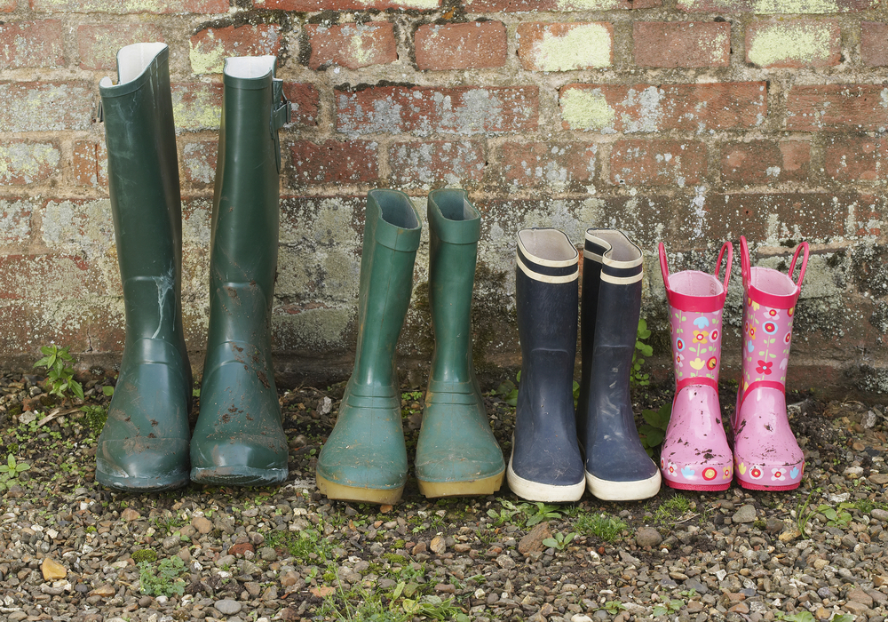

**Premises Development:**

In our last newsletter we outlined our proposals for developing the premises. Whilst this remains in the hands of NHS England for formal approval, we remain hopeful of progress within the next six months. We will update you further when we have some formal announcements to make.

**Appointments:**

Appointments at the Practice have been far more limited than we would have liked, particularly for advanced bookings over recent months.

By the end of September our team will be up to full strength again: We welcome Dr Thomson to a permanent position at the practice, and Dr Alamgir will also return to us towards the end of the month. Sadly, this means that Dr Sultana’s time with us will come to an end. Our appointment availability will improve over the coming months.

Please could you help us to understand your appointment booking needs for seeing the doctors by completing the brief questionnaire which has been in the waiting room since August which will be used to consider ways we can adapt the appointment system to better meet your needs.

Appointments are always likely to be under pressure due to the steady increase in patient demand but this is compounded by the number of patients not attending their pre booked appointments, some of which surprisingly are made on the day. In the last three months we lost **329** appointments of which **104** were doctor’s appointments. **Please** help us keep these to a minimum by letting us know if you are unable to attend; this can be done either by phone or replying to the text reminders which automatically cancels the appointment if not required.

Welcome to the Autumn 2017 Old Fire Station Surgery Newsletter.

**We call it Autumn - The NHS calls it *Flu Season*…**

It is that time of year again. Some of you will have already received a letter *(or text!)* from the surgery regarding your seasonal flu vaccine. We are holding booked clinics during October and November. The seasonal flu vaccination is available free on the NHS for certain criteria’s of people, to help protect adults and children at risk of the influenza virus and its complications. Flu can be unpleasant, but if you are otherwise healthy it will usually clear up on its own within a week.

For those aged 65 and over, pregnant women, and those with a weakened immune system or underlying health condition (including long-term heart or respiratory disease) the flu virus can be severe. Anyone in these risk groups is more likely to develop potentially serious complications of flu, such as pneumonia (a lung infection). The criteria for those eligible for a flu vaccine on the NHS changes from time to time and would ask that if you are 65 or over or normally qualify please contact the surgery to boom your appointment; there is no need to wait for an invite letter but if you have any queries about eligibility, or if you wish to decline your flu vaccine please let us know. Children in reception year and years 1, 2, 3 & 4 and all School children in former pilot areas will have the vaccination in school.

**The Shingles Vaccination**

From September 2017 the shingles vaccination is routinely available to those whom are 70 years old and anyone older born after 1st September 1942 who have not been vaccinated; patients who are 78/79 years old are also eligible BUT only up to 80th birthday.

Autumn marks the transition between Summer and Winter and is the ideal time to ensure your Flu Vaccine appointment has been arranged.

* Eat Well – plenty of colourful fruit and vegetables
* Keep hydrated – even in cooler weather it’s important to drink plenty of clear fluids.
* Keep warm -

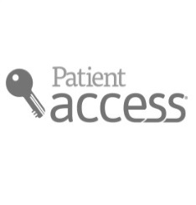

***Have we got your correct Details?***

Please make sure we have your contact details up to date, as we may need to let you know of something with regards to your health. Your GP Surgery is your gateway to the rest of the NHS, so when you change your address and telephone number with us, it is changed across the whole of the NHS. It is also particularly important if you have requested an ***emergency appointment*** to ensure we have the right means of getting in touch.

***Medical School***

Our Practice is a **Training Practice,** and occasionally we will have medical students spend time with our GP’s to learn more about General Practice and in treating particular conditions. If you would like to volunteer to be seen with medical students, and are willing to be contacted when a relevant topic arises, please email us with your **name** and **contact details**, and a list of conditions that you are happy to discuss with the students to ERYCCG.medschool-ofs@nhs.net

***Patient Participation Group*** 🕬The **Patient Participation Group** (PPG) aims to promote co-operation between the Practice and the Patients to the benefit of both. The group meets occasionally to express ideas and to help us provide the best service for you. We welcome new members at any time, if you are interested in joining the PPG, or if you have a question or an issue you would like the PPG to discuss, please forward your discussion items to the following email or ask at reception; [ERYCCG.OFS-PP@nhs.net](mailto:ERYCCG.OFS-PP@nhs.net)

***Waste Medicines Campaign***

Waste medicines cost the UK taxpayers **up to £800 million a year**. In order to help the NHS reduce waste, don’t stockpile medicines and only order what you need to. **Remember,** many of the items you can get on prescription are available to buy.

***Planning your 2017/18 holiday?*** 🏝

Many foreign countries require additional layers of protection when visiting that can include vaccinations or preventative medication. Please let us know **6-8 weeks in advance** if you need any travel vaccinations or are unsure, to allow our nurses to book you in and allow time for the vaccinations to activate

***Text Reminder Service >>> 🖂***

We can use your mobile number to send you text reminders about appointments, and the option to cancel by replying to the text if you are unable to attend the appointment. This will help to reduce the number of appointments not attended.

**Surgery Opening Times**

**Monday 8am – 6pm**.

**Tuesday 8am-6pm.**

**Wednesday 8am-6pm.**

**Please Note: We are closed For Staff training on Wednesdays from 12.45-2pm.**

**Thursday 8am-6pm.**

**Friday 8am-6pm.**

**Please call 111 when you need a doctor outside normal practice hours, weekends and bank holidays.**

**Ordering Your Prescription!**

We receive a high volume of calls on our prescription line.

Please be aware to help both yourselves and us, you can order on this email address:

[**Prescriptions.ofs@nhs.net**](mailto:Prescriptions.ofs@nhs.net)

Please give your name(s) date of birth and address along with the names of the medications and strengths (if variable).

You can do this any time of day, and it will be processed when the prescription desk opens

***✓ Batch Prescribing***

If you have regular repeated medicines, you can ask your Pharmacy to be put on “*batch-prescribing*” where your Pharmacy can request up to 6 months of your medication to be released monthly for you to pick up from them, ready packed!

***✓ Patient Access***

With our online system **Patient Access**, you can book your appointments ahead and also order your repeat prescriptions through the clinical system. To gain access, just ask at reception to fill out a quick form and bring photo ID for them to print your log in details for you.

***✓ Your local Pharmacy***

Please remember you may also be able to organise your requests and deliveries through your regular pharmacy.

**USEFUL NUMBERS**

**OLD FIRE STATION**………………….…... **01482 862236**

SAMMAN ROAD SURGERY……………..01482 882281

SPINKS CHEMIST…………..……………….01482 882562

**CASTLE HILL**……………………………….... **01482 875875**

**HULL ROYAL INFIRMARY**……………....…**01482 328541**

**EAST RIDING HOSPITAL**……………….....**01482 886600**

**SPIRE HULL AND EAST RIDING** ………….**01482 659471**

SINGLE POINT OF CONTACT…………….01482 301701

**PHYSIO DIRECT**……………………….………**01377 208300**