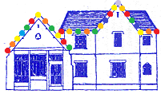
Issue 10:Autumn/Winter 2018
The Old Fire Station Surgery Newsletter

Welcome to our new Practice Nurses.
We are pleased to welcome two new experienced Practice Nurses to the Old Fire Station team, Jo Strachan and Kate Rodgers; they will be working alongside Gina Heath enabling the surgery to continue providing a wide range of nursing care and advice.

Building Update.
The first thing to say is thank you very much for your patience during the building work. This started at the beginning of July but have progressed at the end of October towards completion of the new entrance lobby and patient toilets which are a massive improvement on the old ones and once in use will at least will have something to benefit from. The work is behind schedule for a number of reasons and whilst the original expectation was for the work to be completed by Christmas, this will now run in to the New Year.

Whilst the new treatment room is due to be opened in November, we will be starting work on a new Consulting room (which may mean displacing Dr Carruthers in the short term) and losing the two existing treatment rooms until they are refurbished. It is hoped these will be completed by the end of the year.

Whilst we apologise for the inconvenience, noise and dirt during certain demolition exercises whilst working on the lobby/toilets we will also see some major disruption to the waiting room in the New Year when we commence the final phasing or the work on the waiting room and back office area; we are still working with the builders on this; it does appear we will need to close the waiting room for up to a week in order to allow for the ceiling, flooring and front desk to be removed/reinstalled but will look to update on this nearer the time. We will work to minimise disruption as best we are able and also towards providing some car parking as soon as we are able.

Now we are entering the cooler autumn/winter weather the building should now be a better temperature regulated environment having insulated the roof voids, replaced the old boilers and been provided with a basic temperature regulation system. This will be further enhanced on completion of the work.

Once again thank you for bearing with us, we certainly expect the end results will provide modern 21st century facilities which are practical and pleasing on the eye.
Save money!
Could you benefit from a prescription pre-payment certificate (PPC)? One prescription is currently £9.00

A 3 month PPC costs £29.10 and will save money if you have more than three prescribed items in three months.

A 12 month PPC will cost you £104 and will save money if you need more that 12 prescribed items in a year.

2 items a month – save £105 with 12 month PPC
3 items a month – save £210 with a 12 month PPC
4 items each month – save £315 with a PPC
Ordering your prescriptions.
Now that we are using electronic prescribing it is easier than ever to collect your medications directly from a pharmacy. Simply inform our reception team of your preferred pharmacy and we will do the rest.
We appreciate that the prescription line can be very busy (especially on Mondays – please consider ringing on other days) and would like to remind you that emailing is a stress free 24/7 option. Simply email us your name, DOB and medication names to prescriptions.ofs@nhs.net. Make your life even easier and beat surgery queues by nominating a pharmacy and collecting your order directly from there.

PLEASE ALLOW PLENTY OF TIME FOR ORDERING AND COLLECTING YOUR PRESCRIPTIONS OVER THE CHRISTMAS PERIOD. WE SUGGEST ORDERING AT LEAST ONE WEEK BEFORE CHRISTMAS DAY TO ENSURE YOU HAVE EVERYTHING YOU NEED WITHOUT A LAST MINUTE PANIC.

Checking in for appointments
We would also ask that patients use the self-check-in when arriving for your appointments; it really helps to reduce queues during busy surgery times for those who need to speak to a Receptionist. Our reception staff will be happy assist if necessary.

FLU VACCINATION
- The NHS flu vaccination is available if you;
- Are 65 Years of age and over
- Are Pregnant
- Have certain medical conditions
- Are in long stay/ residential care
- Receive carers allowance or are the main carer for an elderly or disabled patient
- Are a child over 6 months with a long term health condition
- Are a child aged either 2 or 3 on 31 August 2019.

Ear wax removal

Ear Wax removal
This is a service we have historically provided although this isn’t a service the NHS locally considers it appropriate to contract or fund us to provide, unlike some other areas. With the change in nurses the new nurses were not trained at their previous practices to provide this service so we have with some reluctance decided in the short term at least to cease providing this service. We do appreciate the issues/hearing problems this does present for patients having a significant build-up of ear wax and in the event of the need arising would guide patients towards one of the ear wax removal providers locally – this will be chargeable in the similar manner a Chiropodist would for their services. We are considering other options here and will update you should anything change in this respect.
Over the counter medicines
We have been asked by our local NHS finance team not to prescribe Over the Counter medication. Whilst we will endeavour to provide the best possible care we can to all of our patients this is a cost saving measure for the NHS (not the Practice); whilst such items may be free to many of our patients there is still a heavy cost burden for the NHS to pick up which it has been suggested to us may lead to cuts in other services if these costs cannot be reined in.

It would be helpful and save time during your consultations if over the counter medications are not requested but if you disagree with this guidance would recommend you contact the local PALS team at the CCG either on 01482 672047 or ERYCCG.ComplaintsAndConcerns@nhs.net

Planning your 2019 holiday?

Many foreign countries require additional layers of protection when visiting that can include vaccinations or preventative medication. Please let us know 6-8 weeks in advance if you need any travel vaccinations or are unsure, to allow our nurses to book you in and allow time for the vaccinations to become fully effective.

DNA Count!
There were 339 missed appointments in the last two months.
(97 G.P. 121 Nurse. 121 Phlebotomy.)

Please let us know if you are unable to attend; if you have opted in for text reminders you can cancel by replying to these directly.

Nurse Practitioner
Our Nurse Practitioner Nicky Hageman continues to be available for pre-booked and same day appointments on Mondays, Tuesdays, Wednesdays and Thursdays and is able to provide treatment and advice for a range of common illnesses and conditions, she is also able to prescribe where appropriate. She can see both adults and children over the age of two. Please ask our reception team for further information.

Car Parking
Please allow extra time for driving to and parking up for your appointment. The front car park continues to be unavailable during the current alterations and the narrow roads around the surgery can often become clogged with traffic. Please plan in advance for your appointment until the building work is complete.

Are you a carer?
Please let our reception team know, we have carer packs available which are full of information regarding where to go for support, financial assistance and your own wellbeing.

Can our social prescriber help you?
Social Prescribers work alongside our GP’s, Practice Nurses, HCA and other members of the Practice Team to provide personal support to adult patients in the East Riding who would like help with their social, emotional and practical needs. This could be help with social isolation, emotional wellbeing, exercise, smoking cessation and much more. They are here at the practice 2 days each week and are also available for telephone support and home visits if required.

Fee also works closely alongside Health trainers. If you would like to become fitter and are unsure as to where to start a health trainer will help you work out exactly what you are looking to achieve and how you can go about doing this. They can offer advice with the following; healthy eating, losing weight, physical activity, giving up smoking, cutting down on alcohol and reducing stress and anxiety.

Text Reminder Service >>>

We can use your mobile number to send you text reminders about appointments and has the option to cancel by replying to the text if you are unable to attend the appointment. This will help to reduce the number of appointments not attended.

Have we got your correct Details?

Please make sure we have your contact details up to date, as we may need to let you know of something with regards to your health. Your GP Surgery is your gateway to the rest of the NHS, so when you change your address and telephone number with us, it is changed across the whole of the NHS. It is also particularly important if you have an emergency need to ensure we have the right means of getting in touch.
Medical School 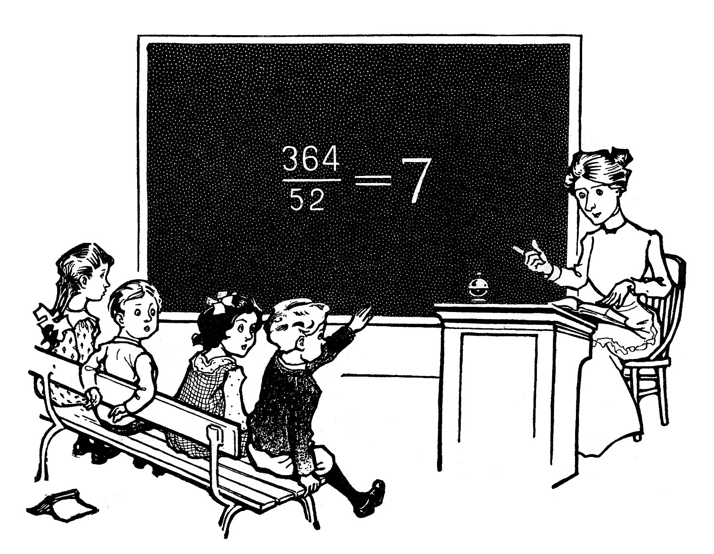
Our Practice is a Training Practice, and occasionally we will have medical students spend time with our GP’s to learn more about General Practice and in treating particular conditions. If you would like to volunteer to be seen with medical students, and are willing to be contacted when a relevant topic arises, please email us with your name and contact details, and a list of conditions that you are happy to discuss with the students to ERYCCG.medschool-ofs@nhs.net

Christmas and New Year 2019 Opening Hours

Tuesday 24th December - Open as usual
Wednesday 25th – Thursday 26th December – Closed
Friday 27th – Open as usual
Saturday 28th – Sun 29th Closed
Monday 30th December 2018 - Open as usual
Tuesday 31st January – Open as usual
Wednesday 1st January – Closed
Thursday 2nd January – Open as usual
Friday 3rd January – Open as usual

Our Wednesday evening clinics will be changed but these will be advised separately.

