***Regular Opening Hours***

**Monday 08.00 – 18.00  
Tuesday 08.00 – 18.00**

**Wednesday 08.00 – 21.00*  
(Please note we close weekly for training   
on WEDNESDAYS between 12.45 – 14.00)  
Thursday 08.00 – 20.00*  
Friday 08.00 – 18.00**

**\*For appointments only**

**Spring 2024**

**Message from the Practice Manager.**

During the winter months we have seen an increased demand on the practice’s services, despite having a full team of doctors. As a result, our same day appointments have been used sooner than we would wish. The GPs are looking to review the booking system to accommodate some additional prebook able appointments where needed.

Please remember our team are here to help you and are trying their hardest to accommodate your needs, please be kind.

In December and January, we had **176** No Shows for Nurse and phlebotomy appointments, which could have been used by other patients.

If you need to cancel or rearrange your appointment, please let us know in plenty of time if possible, so that we can offer it to another patient.

**Did you know…?**

* General practice receives a £107 payment per patient per year.
* The news coverage of the hospital doctor, nurse and staff pay.

increases in 2023 did **not** apply to General Practice

* The pay scales for other parts of the NHS work on higher pay levels and include additional annual incremental pay increases above the publicised pay increase and neither apply to general practice.
* General Practice saw an increase of less than 6% in 2023/24 and

proposals are for a 2.1% increase in 2024/25

* Our increases have to cover all costs including utility and staffcosts, starting with the increase of 19.5% in National Minimum wage 2023 -25
* 31% average drop in GP contractor earnings before tax for

2022/23 compared with the previous year.

* There were6.25 million - extra NHS general practice patients in Jan 2024 compared to 2015.
* 1.39 million average daily appointments delivered in general practice across England.
* 5-6% only of the overall NHS budget is spent on general practice-level contracts in England in 2022/23 (and reducing) (latest data)
* There are 1,900 fewer full time, qualified GPs since September 2015 when 6,000 additional GPs in 2019 were proposed.

**Is it possible that the diversion of funds away from general**

**practice could see the demise of this service like**

**dentistry….?**

**Issue 26: Spring 2024**

***Bank Holidays to keep in your diary***

***Easter Bank Holiday***The Surgery will be closed on **Friday 29th March** and reopen on **Tuesday 2nd April**.

***Mayday Bank Holiday***

The Surgery will be closed on **Monday 6th May** for the May Day Bank Holiday.

***Spring Bank Holiday***

The Surgery will be closed on **Monday 27th May** for the Spring Bank Holiday.



**The easy way to order your prescriptions.** Ordering by email is quick, easy and can be done at any time to suit you. We will need your name, D.O.B. and the names of the medications you wish to order. They will be sent directly to your pharmacy -**Simply email us at** [Prescriptions.ofs@nhs.net](mailto:Prescriptions.ofs@nhs.net)

**YOU DO NOT NEED TO PHONE.**

**Happy with your experience? Let us know and leave a Google review**

**YOU DO NOT NEED TO PHONE.**

**ONLINE ACCESS**

***Did you know that all our routine GP appointments, released on the day at 8.00am are now bookable online***. We realise that not everyone finds it easy to use the phone during working hours, whilst commuting or the school run. This means you will now have easy online access at 8.00am prompt to book appointments **on the day** or prebook able availability.

If you wish to register for online access, please bring photo I.D. and current proof of residence. Then complete the application form available at our reception. (Over 18’s only).

You can also download the NHS App on your smart phone and use it to book appointments and reorder repeat medications. You do not need to visit the surgery or fill in any forms to do this, simply download the app and follow the instructions you are given.

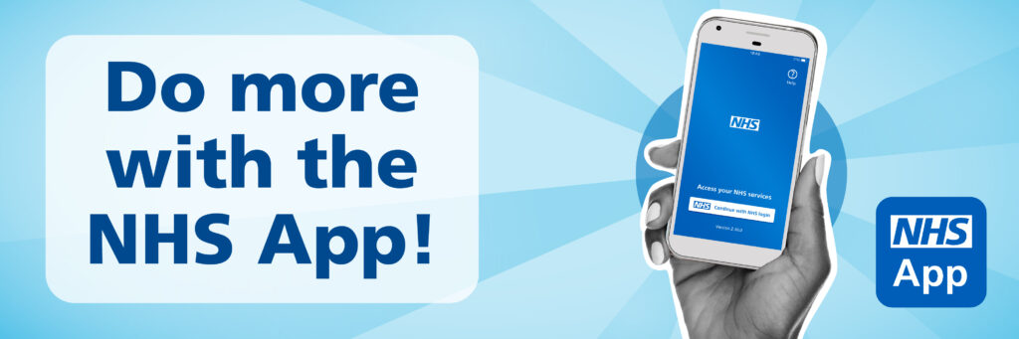

***Please note this scheme is not suitable for recurrent problems.***

**Self- Referral Services.**

**Stop Smoking- City Health Care Partnership**

Call 0800 915 59 59 or text QUIT to 611825

[www.readytostopsmoking.co.uk](http://www.readytostopsmoking.co.uk)

**Alcohol & Drugs Services**

01482 336675 – self referral 9am-5pm

**Mental Health and Wellbeing Coach**

If you are struggling with low mood, anxiety, depression you can self-refer for free, confidential 1:1 support.

0800 91777752

**Adult Mental Health Services**

24-hour self-referral including Crisis Team

01482 301701

**Child & Adolescent Mental Health Services**

01482 303810 9am-5pm for self-referral

01482 301701 Option 1

5pm- 9am Out of Hours crisis team

**Domestic Violence Adult Services**

01482 396330

**SPRING FEVER!**

As the (hopefully) better weather approaches seasonal problems such as hay fever begin to take effect; please remember your pharmacist can assist with most hay fever queries and should be the first port of call for insect bites that are not severe. Often over the counter treatment costs a fraction of the price of the standard prescription charge of £9.65 per item.

***CERVICAL SCREENING SAVES LIVES***

The aim ofthe NHS cervical screening programme, which commences at age 25, is to reduce the number of women who develop cervical cancer and the number of women who die from the condition. Alarmingly there seems to be an increasing number of women who are not attending for cervical smears when they receive a letter to attend. We would like to address this issue at our practice as early detection and treatment of cervical cancer can save lives. If you have received an invite and are anxious about attending, please contact the surgery and one of our friendly nursing team will be more than happy to discuss the procedure with you in private and address any of your concerns.

**PLEASE DO NOT IGNORE YOUR INVITE TO ATTEND.**

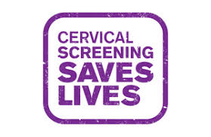



*The Practice is actively looking to recruit working age people to join our Patient Participation Group. We are keen to hear your views on booking appointments and how we can help to meet your needs. Meetings are held twice a year.*