**Autumn/Winter 2025**

**News from the Practice Manager**

**New Telephone System**

We are scheduled to have our telephone system replaced in the second half of October. This will provide some additional features for patients, including a queuing system and the ability to have a call-back rather than wait in the queue. There will be some other minor changes and your patience would be appreciated during the transition, albeit we are not expecting any disruption to our services.

**Car Park**

The patient car park has recently undergone some changes, having been partially re-lined in order to make parking easier with larger offset spaces and a turning circle together; we do ask that the turning area in front of Spinks is not used for parking, however short the stay is. New extended ramps up to the main entrance and into the Annexe should improve access to both entrances and we are also awaiting the installation new signage and a fence installed in order to prevent falls off the kerb.

**Flu Vaccinations**

The flu vaccination programme commenced in September for pregnant women, infants aged 2 and 3 and at risk 18 year olds.

The 65 year old and above together with the at-risk 18-64 year old programme will commence at the beginning of October in line with NHS regulations.

*Eligible patients will receive an invitation from the surgery. If you have a smart phone, you will be sent a link allowing you to book online. This is the fastest and easiest way to book. Otherwise, you will be contacted by letter.*

**Covid Vaccinations**

Please contact the Covid Helpline by calling 119 or book online for those eligible for a Covid Autum booster for the 75 and old age group; the surgery is **not** providing these vaccinations.

**New patients?**

We are pleased to welcome new patients and believe we are well placed to provide a comprehensive and easily accessible service from our highly experienced team. You can submit a registration online following the link on our website, or if you prefer to use pen and paper, printed registration forms are available at reception.

**Long Term Condition Annual Reviews**

We have introduced a **new annual review recall process**, which we hope will be more efficient and less time consuming for patients~~.~~

As part of the new process, we’ll invite you for a Long-Term Condition (LTC) annual review during or around your birth month. If your birthday is in April for example, you will receive an invite from the practice during that month, or before. Using your birth month makes it easier for you to predict, especially if you have more than one condition, and it’s much more efficient for your overall care. Our team will get in touch when it's time to book.

***Regular Opening Hours***

**Monday 08.00 – 18.00  
Tuesday 08.00 – 18.00**

**Wednesday 08.00 – 21.00*  
(Please note we close weekly for training   
on WEDNESDAYS between 12.45 – 14.00)  
Thursday 08.00 – 20.00*  
Friday 08.00 – 18.00**

**\*For appointments only**

**Issue 30: Autumn/Winter 25.**

***Bank Holidays to keep in your diary***

***Christmas 2025***

**The Surgery will be closed on Thursday 25th and Friday 26th December and will reopen on Monday 29th December.**

**We are also closed on Thursday 1st January.**

**The easy way to order your prescriptions.** Ordering by email is quick, easy and can be done at any time to suit you. We will need your name, D.O.B. and the names of the medications you wish to order. They will be sent directly to your pharmacy -**Simply email us at** [Prescriptions.ofs@nhs.net](mailto:Prescriptions.ofs@nhs.net)

**YOU DO NOT NEED TO PHONE.**

**Happy with your experience? Let us know and leave a Google review**

**YOU DO NOT NEED TO PHONE.**

***Please note this scheme is not suitable for recurrent problems.***

**ONLINE ACCESS**

***Did you know that all our routine GP appointments, released on the day at 8.00am are now bookable online***. We realise that not everyone finds it easy to use the phone during working hours, whilst commuting or the school run. This means you will now have easy online access at 8.00am prompt to book appointments **on the day** or prebook able availability.

If you wish to register for online access, please bring photo I.D. and current proof of residence. Then complete the application form available at our reception. (Over 18’s only).

You can also download the NHS App on your smart phone and use it to book appointments and reorder repeat medications. You do not need to visit the surgery or fill in any forms to do this, simply download the app and follow the instructions you are given.

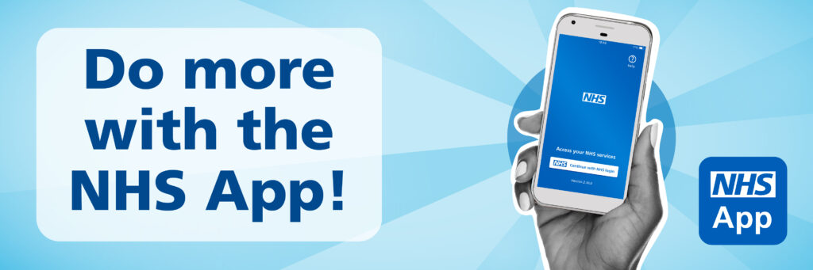

**Self- Referral Services.**

**Stop Smoking- City Health Care Partnership**

Call 0800 915 59 59 or text QUIT to 611825

[www.readytostopsmoking.co.uk](http://www.readytostopsmoking.co.uk)

**Alcohol & Drugs Services**

01482 336675 – self referral 9am-5pm

**Mental Health and Wellbeing Coach**

If you are struggling with low mood, anxiety, depression you can self-refer for free, confidential 1:1 support.

0800 91777752

**Adult Mental Health Services**

24-hour self-referral including Crisis Team

01482 301701

**Child & Adolescent Mental Health Services**

01482 303810 9am-5pm for self-referral

01482 301701 Option 1

5pm- 9am Out of Hours crisis team

**Domestic Violence Adult Services**

01482 396330

KEEPING WARM THIS WINTER

Am I eligible for Winter Fuel Payment?

If you were born on or before 22 September 1958 and receive Pension Credit, Universal Credit, Income Support, income-based Jobseeker’s Allowance or income-related Employment and Support Allowance, you're likely to qualify for a Winter Fuel Payment in the winter of 2024-25, as long as you were living in Great Britain during the qualifying week.

The qualifying week is the week beginning from the 3rd Monday in September. This is 16 to 22 September 2024. If you earn more than £35,000 HMRC will reclaim the payment.

If you think you may be eligible for extra support, please contact age concern who can help to check this for you. Tel 0800 678 1602.

**Sepsis**

**What is Sepsis?**

Sepsis is a life-threatening reaction to an infection.

It happens when your immune system overreacts to an infection and starts to damage your body’s own tissues and organs.

You cannot catch sepsis from another person.

Sepsis is sometimes called septicaemia or blood poisoning.

**Symptoms**

Sepsis is **life threatening** and it can be hard to spot.

There are lots of possible symptoms.

They can be like symptoms of other conditions, including flu or a chest infection. If you think you or someone you look after has symptoms of sepsis, **call 999 or go to A&E. Trust your instincts.**



*The Practice is actively looking to recruit working age people to join our Patient Participation Group. We are keen to hear your views on booking appointments and how we can help to meet your needs. Meetings are held twice a year.*